- JOB ID: 1100flo141757020243442_CT.pdf
PAGE # 4
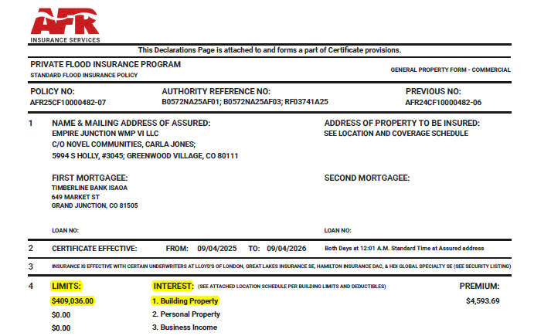
PAGE # 5
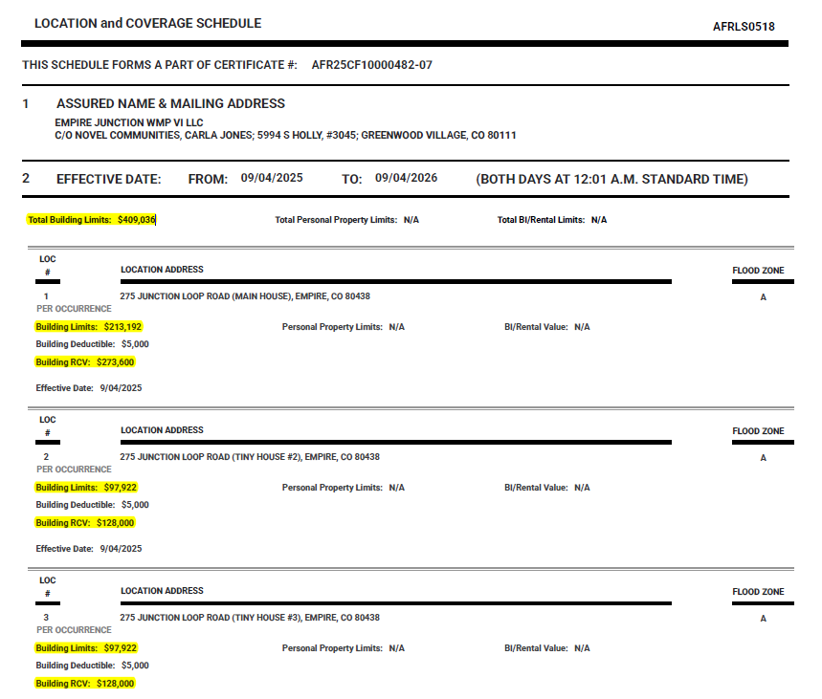

- JOB ID: 1010flo202509060231003004_CT.pdf
PAGE # 1
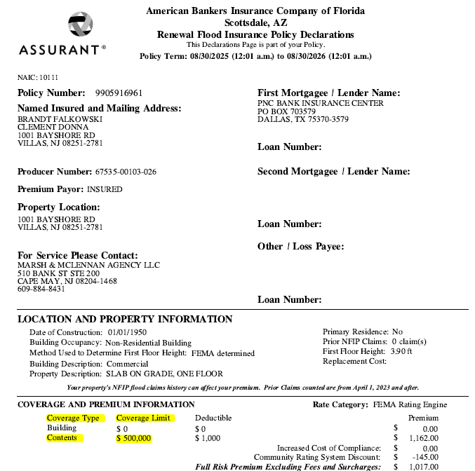

- JOB ID: 1150flo202508270506259001_CT.pdf
PAGE # 1

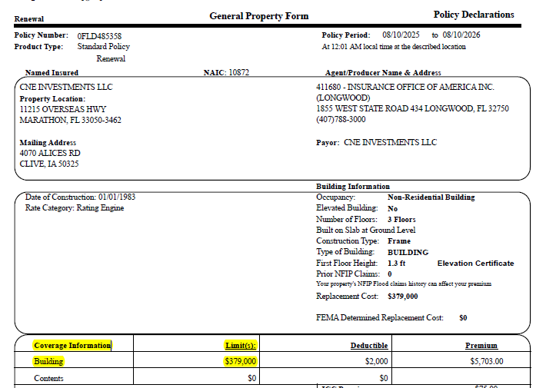
- JOB ID: 1151flo202508270120236010_CT.pdf
PAGE # 23
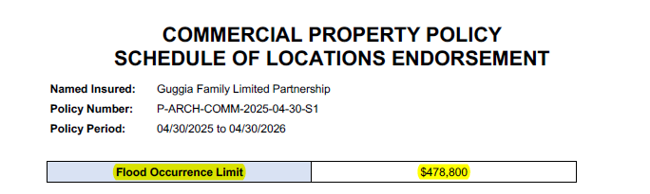

PAGE # 24
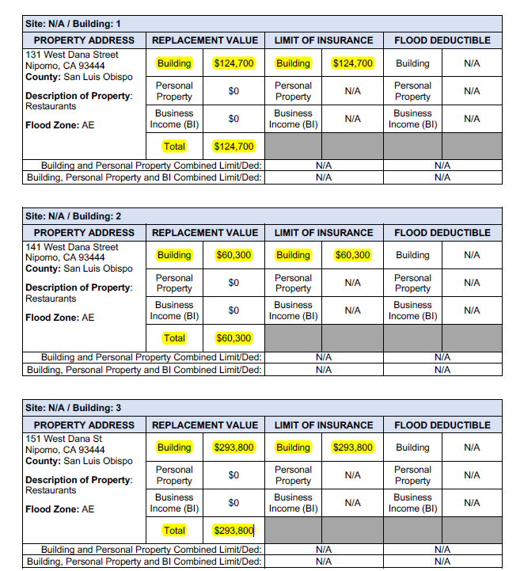

PAGE # 25
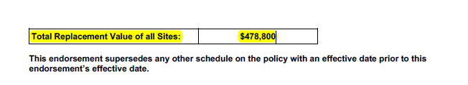

- JOB ID: 1151flo202508270120236010_QUOTE.pdf
PAGE # 4


PAGE # 7
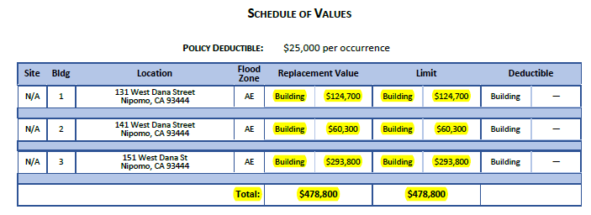

- JOB ID: 1090flo202508281455476006_CT.pdf
PAGE # 5
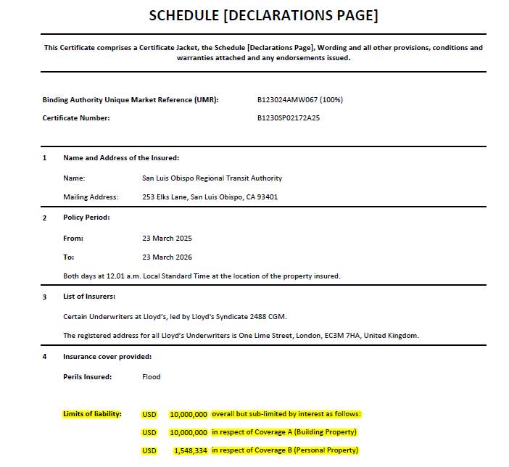
PAGE # 7
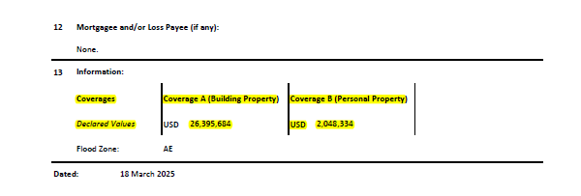

- JOB ID: 1090flo202508281455476006_Binder.pdf
PAGE # 7
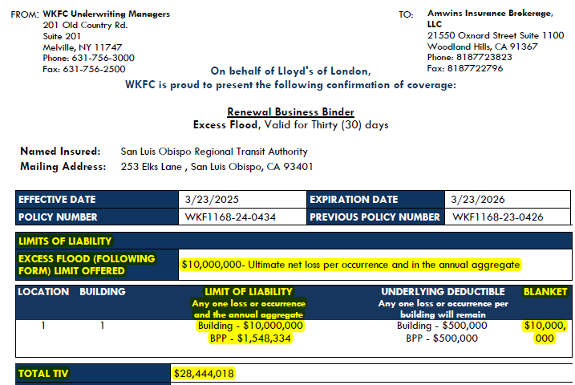

- JOB ID: 1090flo202508292112067004_CT.pdf
PAGE # 9
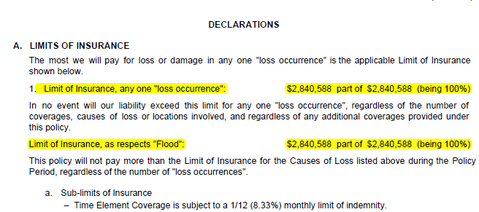
PAGE # 11
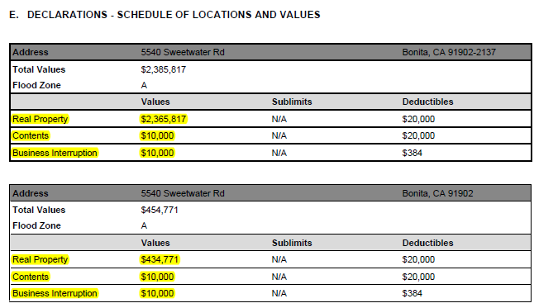

- JOB ID: 1090flo202508292112067004_Quote.pdf
PAGE # 1
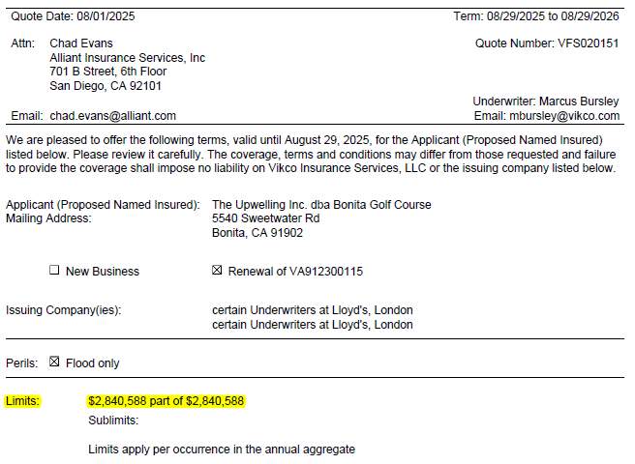
PAGE # 2
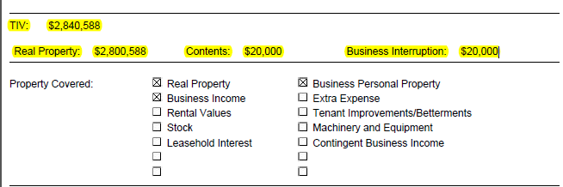
- JOB ID: 1099flo202509041537279_CT.pdf
PAGE # 5
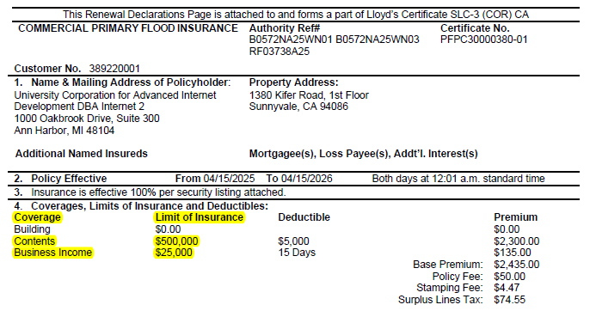
- JOB ID: 1099flo202509041537279_Binder.pdf
PAGE # 8
